**1 Simple output to screen**

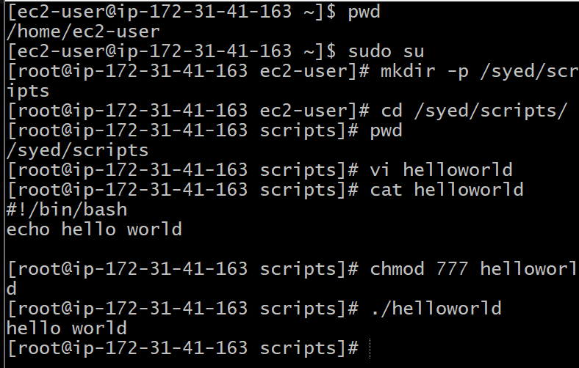

**Script:**  
#!/bin/bash  
# Simple output script  
echo "Hello World"

**2. Output permission**

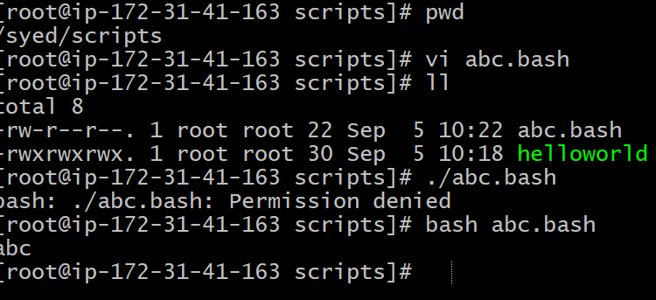

**3. Comands Scripts:**

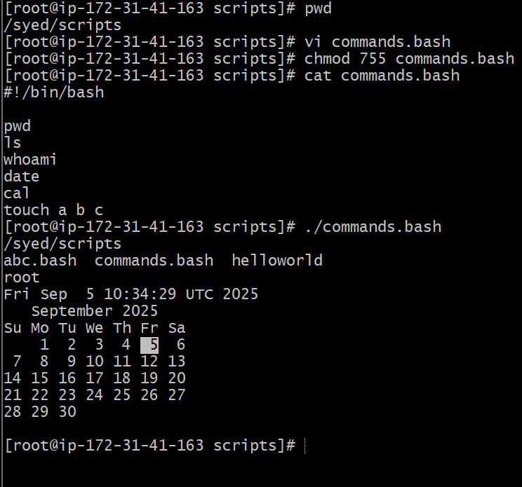

**Script:**

#!bin/bash

Pwd

Ls

Whoami

Cal

Touch a b c

**4. Define small tasks:**

**Script:**

whoami

echo

pwd

echo

hostname

echo

ls -ltr

echo

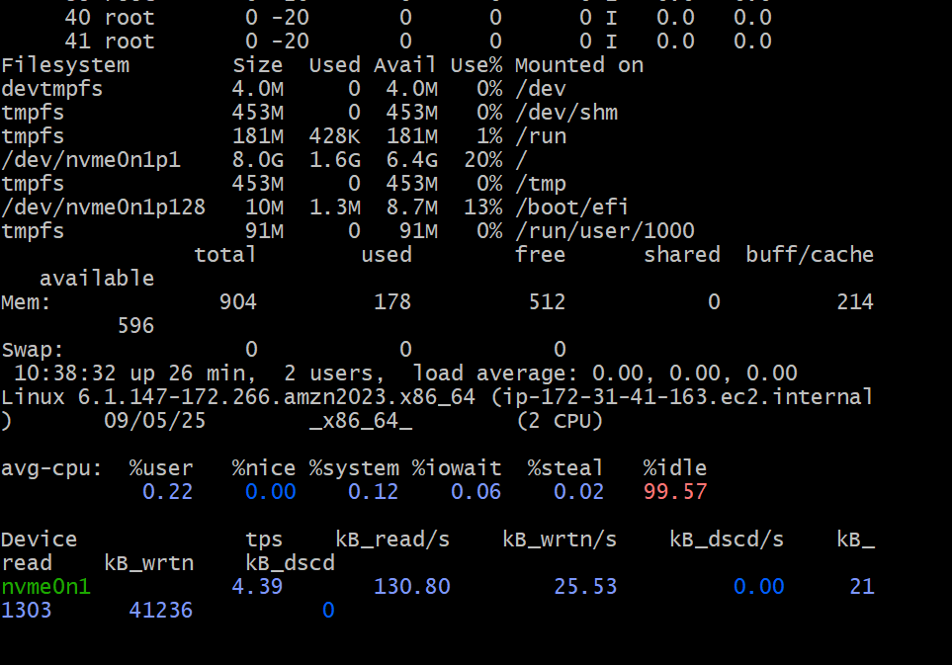

**5. Read Input:**

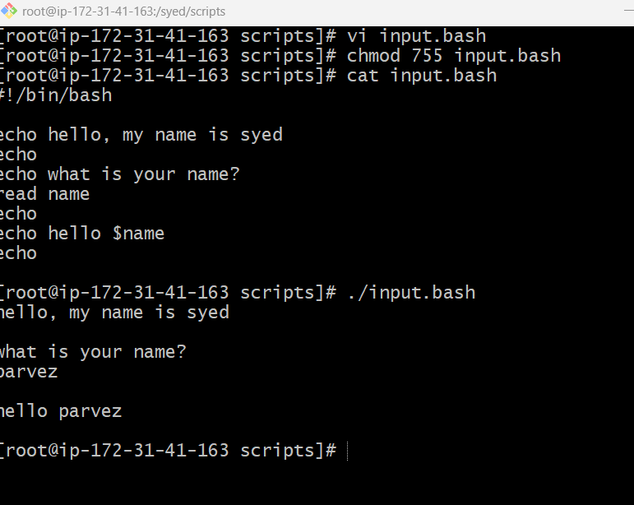

**Script:**

* Create a file and write the script which takes input from the user:
* Change the permission: chmod 755 input.sh
* “Enter your name” and it will display the output.

**7. Read input and perform a task:**

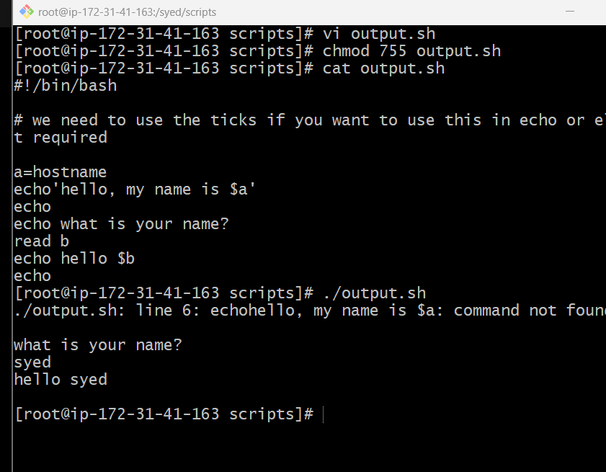

**Steps:**

* Create a file and write the script which takes input from the user:
* Change the permission: chmod 755 output.sh
* “Enter your name” and it will display the output.